CO21BTECH11002

Aayush Kumar

Assignment – Eigenvalues

Algorithm:

To get QR factorization:

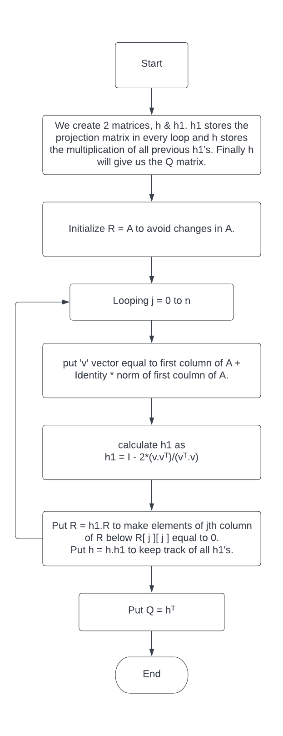

1. Without Calculating Hessenberg Matrix:

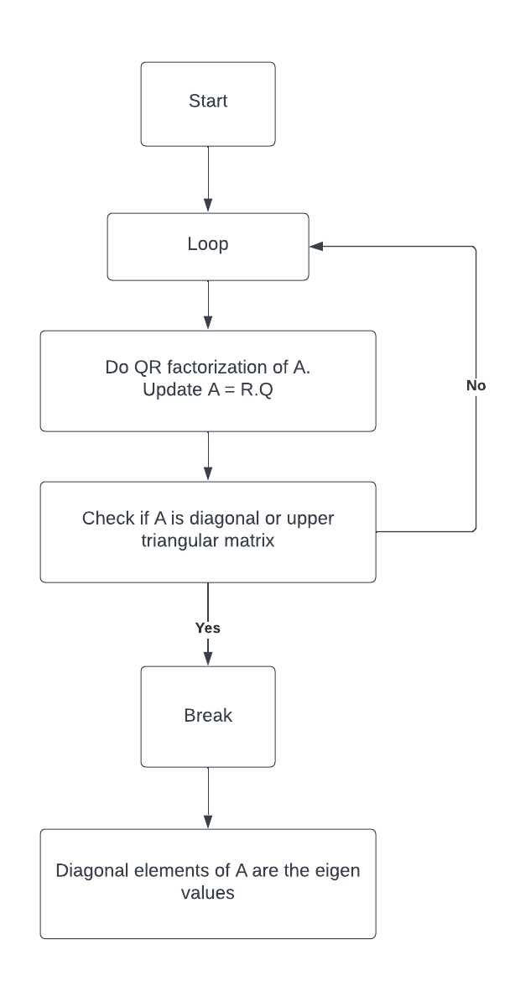

1. After calculating Hessenberg Matrix:

To get Hessenberg Matrix:

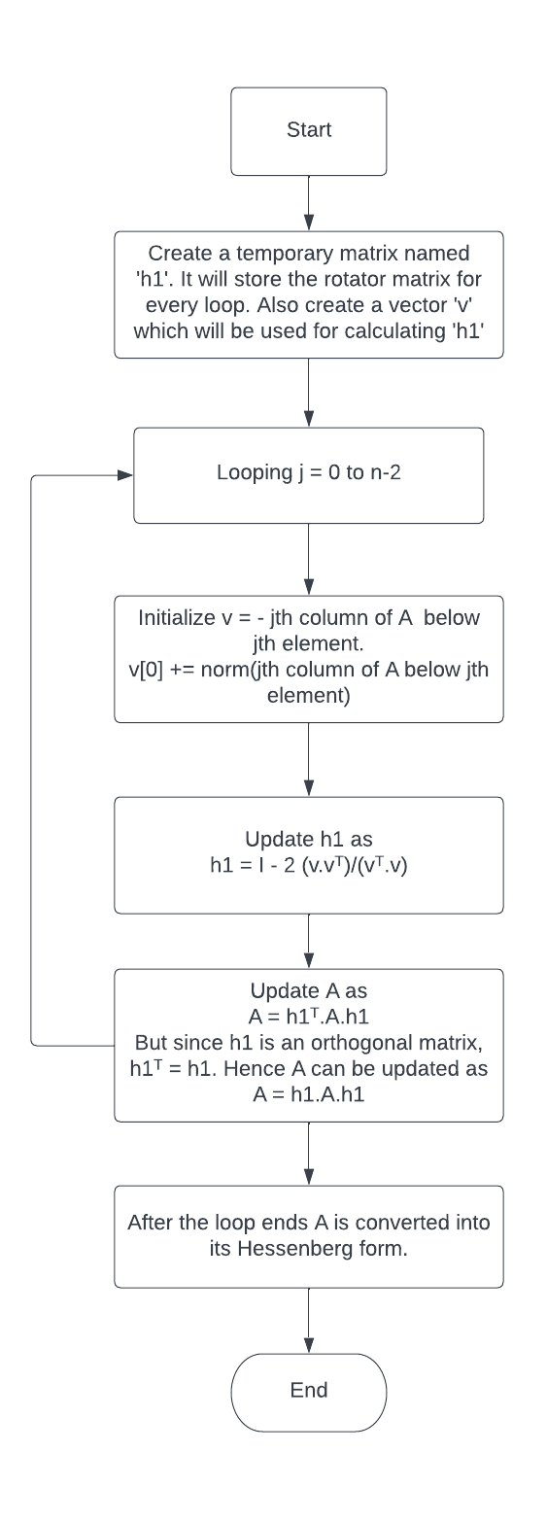

Now that we have our Hessenberg matrix, we can use the method of QR factorization with shifts to get eigenvalues.

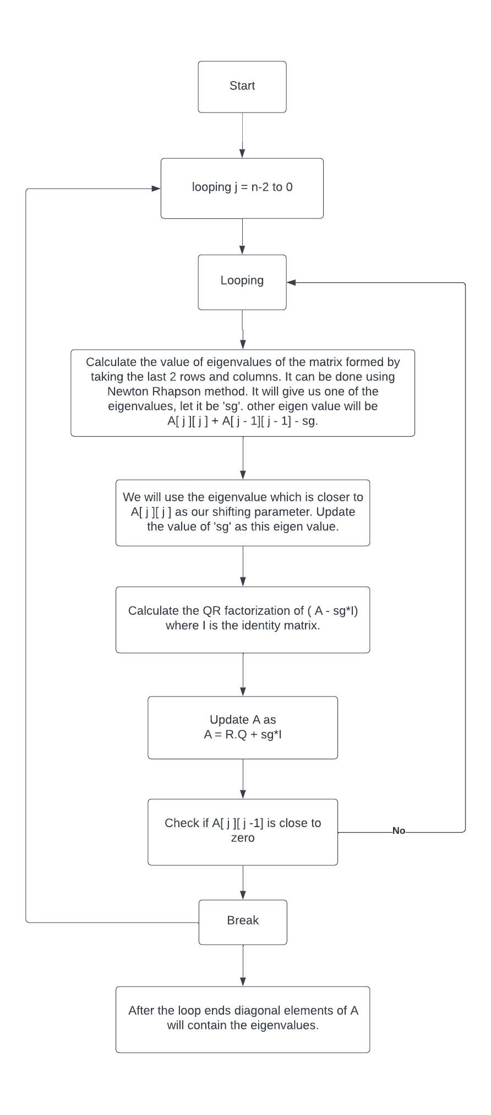

Input:-

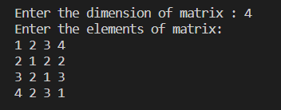

Output:-

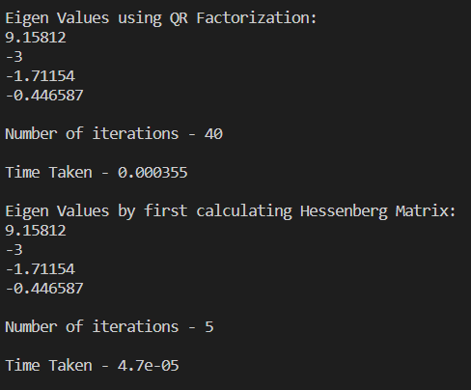

Hence, we can see that for this example finding Eigen Values after finding the Hessenberg matrix is almost 8 times faster and also converges in just 5 iterations while the first method took 40 iterations.